**s o f i a**

**Future Developments Proposal**

*Potential Future Product and Business Ideas to Consider*

**Document Control**

|  |  |  |  |
| --- | --- | --- | --- |
| **Editor** | **Version** | **Date** | **Update** |
| **Alex Cash** | **1.0** | **02/06/2015** | **Created document** |

**Table of Contents**

1.0 Introduction 4

2.0 Moving to the Cloud 4

2.1 Initial Proposal 4

2.2 Justification 4

3.0 Generating a Community 6

3.1 User Forums 6

3.2 Direct Customer Communications 6

4.0 Going Global 6

5.0 Summary 7

**Future Development Proposal**

# 1.0 Introduction

We have a number of ideas of how to progress the company moving forward into the future. These have been briefly outlined in our company presentations but shall be discussed in more detail in this proposal. All of the information in this document is based on market research and speculation. Finances for any proposals have not been calculated and would need to be investigated before anything new could be implemented.

# Moving to the Cloud

2.1 Initial Proposal

The core development upon which most other proposals are based on is a move towards a cloud based platform. At the heart of this move would be improvements to usability; allowing paying customers (teachers or tutors) to upload lesson plans online, share them with colleagues, and manage work assigned to students through a web browser. The first step would be to implement updating modules into both TeachEasy and LearnEasy; these would automatically connect so sofia cloud servers to communicate with our cloud platform. The envisioned process for a teacher would be:

* Register students online and organise them into groups
* Create a lesson in TeachEasy
* Upload it to the sofia Cloud from within TeachEasy. The lessons would all be stored within their account for as long as they wish
* Log in to the sofia Cloud via a web browser
* Assign lessons to groups or classes of students
* Track which students have completed which lessons and how well they have done

On the other end of the product, when a student logs in to LearnEasy, the software will automatically connect to the cloud and as such download any lessons assigned to them by their teacher or tutor. It will also automatically upload their marks once they have completed each lesson for their teacher to view online.

2.2 Justification

We believe this change will vastly improve usability and simplify the whole process for both paying customers and their students. This will also simplify lesson organisation for the teachers along with tracking the progress of their students; thus drawing in new customers through the product’s reputation among educators. We believe this will add a huge amount of value to the product relatively quickly and without too much expense for sofia.

Our current method can be simply described by the following diagram:

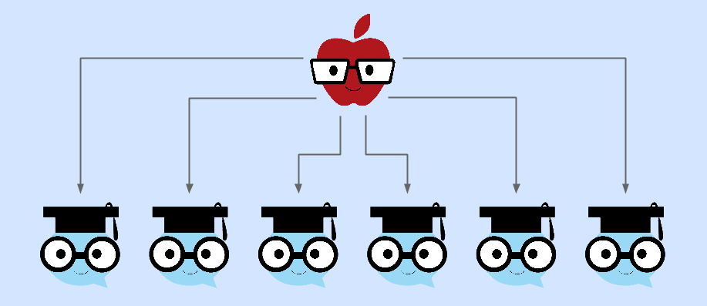

Whereby the teacher has to create the lesson and manually distribute it to their students via email or some other medium. The cloud platform we would like to move to can be displayed as:

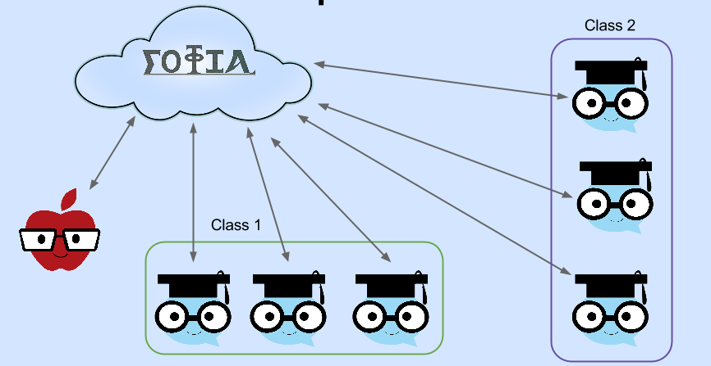

Here it is clear to see that our new system simplifies the lesson distribution for the teachers and can be used to organise students. This will also add an automated and centralised progress tracking location once again making it easier for educators to see how each and every student is doing, enabling them to cater to specific students’ needs.

# Generating a Community

3.1 User Forums

We strongly believe that for a software product to survive and more importantly thrive in modern times, it is important to develop an active community around your products. Many software products such as video games succeed for long periods of time due to user created content, and we believe our products have the necessary features to enable this too.

We plan to create user forums exclusively for paying customers (educators) to discuss, share, and modify lesson plans. We believe this will add yet another way for teachers to save time by using our products, as they can design lessons to fit a certain syllabus and share it on our forum for other users to use as they please.

This forum will be implemented with the sole aim of generating a community surrounding our products with the hope of sustaining our products into the future as well as encouraging new users to join our platform.

3.2 Direct Customer Communications

Although we will run and use the obvious social media platforms such as Twitter and Facebook, we feel that allowing interaction with our customers through our website, email, and forums will encourage an open discussion. We aim to be able to discuss future developments, promotional offerings, and any new products we may aim to release. We feel this is a great way to encourage trust in our company, by being transparent and direct with communications we can inspire faith in both our products and our company’s ethos.

This will also allow us to garner general opinion of our product as well as any features that customers feel aren’t up to scratch or need extending or improving. This provides us with a way to deliver exactly what customers want as soon as possible.

# Going Global

Once we are well established in the UK and have become a recognisable brand, the only way for us to expand (short of encouraging more UK based customers to join up) is to extend overseas. Naturally, the first steps for us would be to focus on English speaking languages and in particular we would target:

* The USA
* Canada
* New Zealand
* Australia

Moving forward would require us to extend language support to cover other languages. Our first product versions that support foreign languages would target countries within the EU due to simpler trade regulations, and to research the most beneficial markets for our company.

Going global would most likely require our cloud system to be in place, but is not absolutely necessary.

# Summary

As can be seen, we have a number of ideas for expansion to benefit our employees, the company, and our investors. In particular we have plans to both improve the product, and to expand our user base; both of which would help us to generate increased profits.